**News Release**

**onsemi Launches MOSFETs With Innovative Top-Cool Packaging**

*Top-side cooling simplifies design and reduces cost for compact power solutions*

**MUNICH – Nov. 15, 2022 –** **onsemi** (Nasdaq: ON), a leader in intelligent power and sensing technologies, today announced a series of [new MOSFET devices](https://www.onsemi.com/products/discrete-power-modules/mosfets#products=fi0xMX52YWx1ZX4xflRDUEFLMTAgNS4xeDcuNSwgMS4wUH4=) that feature innovative top-side cooling to assist designers in challenging automotive applications, especially within motor control and DC/DC conversion. The company is showing the new devices at its booth 101 in hall C4 at [electronica](https://electronica.de/en/), the world’s leading trade fair and conference for electronics.

Housed in a TCPAK57 package measuring just 5mm x 7mm, the new Top Cool devices feature a 16.5mm2 thermal pad on the top side. This allows heat to be dissipated directly into a heatsink rather than via a typical printed circuit board (PCB). By enabling the use of both sides of the PCB and decreasing the amount of heat going into it, the TCPAK57 provides increased power density. Improved reliability of the new design adds to an overall extended system lifetime.

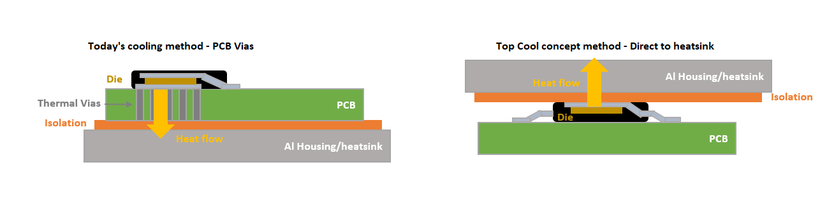

“Cooling is one of the greatest challenges in high power design and successfully addressing it is the key enabler to reducing size and weight, which is critical in modern automotive design,” said Fabio Necco, vice president and general manager, Automotive Power Solutions at onsemi. “With excellent electrical efficiency and having eliminated the PCB from the thermal path, the design is significantly simplified while reducing size and cost.”

The devices deliver the electrical efficiency required in high power applications with RDS(ON) values as low as 1mΩ. Additionally, the gate charge (Qg) is low (65 nC), reducing losses in high-speed switching applications.

This solution leverages onsemi’s deep expertise in packaging to provide the highest power density solution in the industry. TCPAK57 initial portfolio includes 40V, 60V and 80V. All devices are capable of operating at junction temperatures (Tj) of 175°C and are AEC-Q101 qualified and PPAP capable. This, along with their gull wings that allows inspection of solder joints and superior board level reliability, makes them ideally suited to demanding automotive applications. The target applications are high/medium power motor controls such as electric power steering and oil pumps.

Samples of the new devices are available now with full-scale manufacture planned in January 2023. Please [contact our sales office.](https://www.onsemi.com/support/sales)

**More information on the Single N-Channel Power MOSFETs on Top Cool Package can be found on our website** [**here**](https://www.onsemi.com/products/discrete-power-modules/mosfets#products=fi0xMX52YWx1ZX4xflRDUEFLMTAgNS4xeDcuNSwgMS4wUH4=)**.**

###

**About onsemi**

**onsemi** (Nasdaq: ON) is driving disruptive innovations to help build a better future. With a focus on automotive and industrial end-markets, the company is accelerating change in megatrends such as vehicle electrification and safety, sustainable energy grids, industrial automation, and 5G and cloud infrastructure. **onsemi** offers a highly differentiated and innovative product portfolio, delivering intelligent power and sensing technologies that solve the world’s most complex challenges and leads the way to creating a safer, cleaner, and smarter world. **onsemi** is recognized as a Fortune 500® company and included in the S&P 500® index. Learn more about **onsemi** at [www.onsemi.com](http://www.onsemi.com).

*onsemi and the onsemi logo are trademarks of Semiconductor Components Industries, LLC. All other brand and product names appearing in this document are registered trademarks or trademarks of their respective holders.*

**Contacts**

**Stefanie Cuene**

Head of Public Relations  
onsemi   
(602) 315-3778  
Stefanie.Cuene@onsemi.com

**Parag Agarwal**Vice President - Investor Relations & Corporate Development  
onsemi  
(602) 244-3437  
[investor@onsemi.com](mailto:investor@onsemi.com)